**User manual**

**Run file**

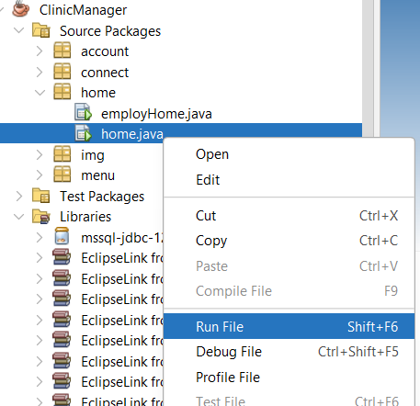

Go to ClinicManager -- > Source Package -- > home -- > Right click on home.java then select Run file

**Login:**

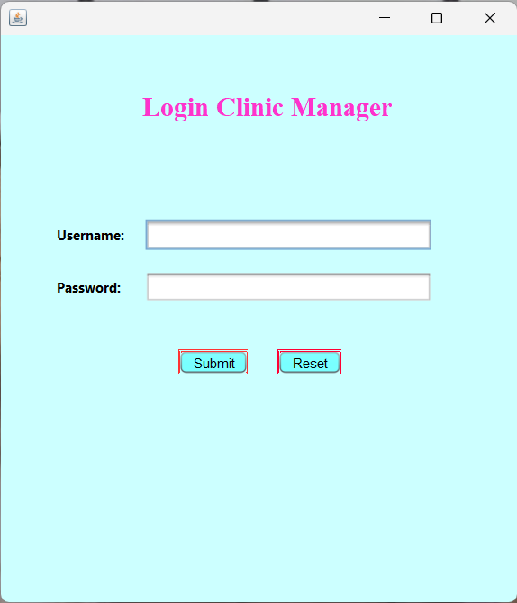

Login is used to log in to the admin and user pages

Login password

admin page is:

User: admin

Password: admin

*IMG_256*

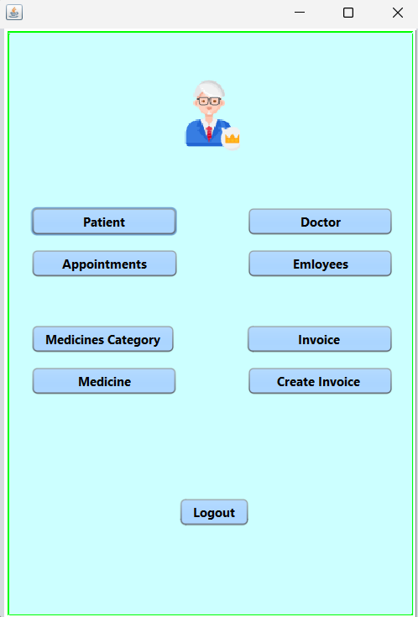

This is the main interface of the clinic management program. Main functions such as patient management, appointment, medicine Caterogy , Medicine, create invoice, invoice and sign out.

User has the functions patient, invoice, create invoice, appointment

Patient:Has the function of adding, editing, and deleting patients

Doctor:Has the function of adding, editing, and deleting patients

Appointment:Has the function of adding, editing, and deleting patients

Employee:Has the function of adding, editing, and deleting patients Medicine Caterogy:Has the function of adding, editing, and deleting patients

Invoice:Has the function of adding, editing, and deleting patients

Medicine:Has the function of adding, editing, and deleting patients

Create invoice:Has the function of adding, editing, and deleting patients

**Edit function:**

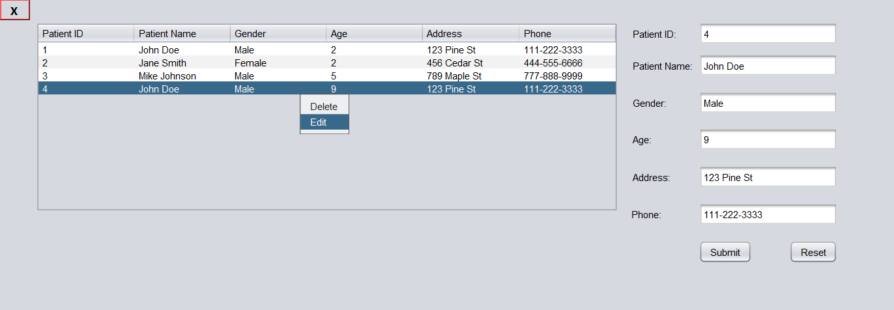

Right click on the data you want to edit then select edit when finished editing click save

**DELETE Function:**

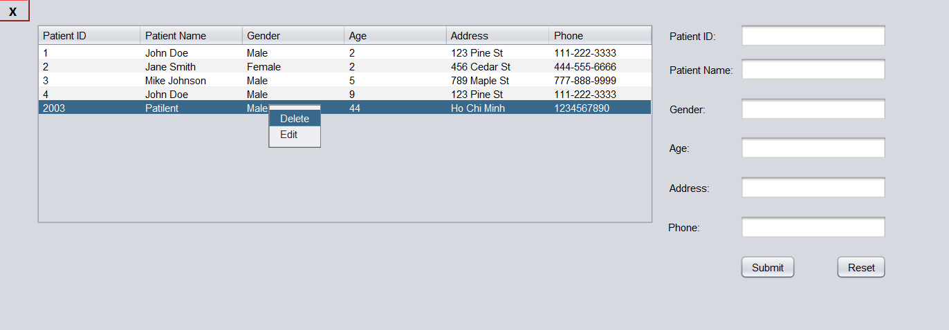

Right-click on the data you want to Delete then select Delete. The data will be deleted

**Add data:**

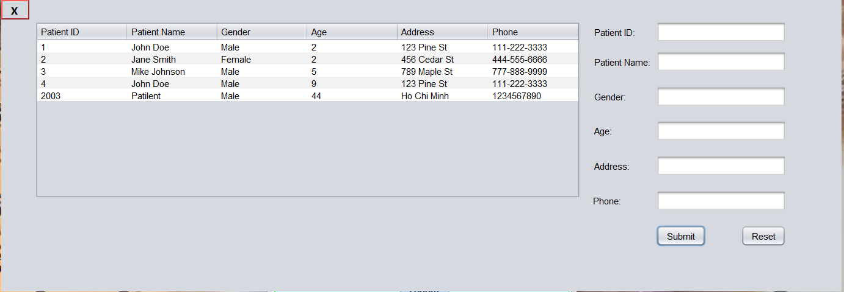

**Add valid data then select Save:**

**Create invoice:**

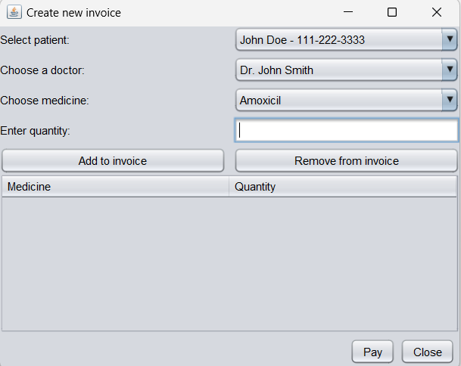

-Step 1: select patient

-Step 2: select doctor

-Step 3: select medicine

-Step 4: enter quantity

-Step 5: is pay

Remove from invoice: select the data you want to delete in the table then press remove

1 :Invoice check Right click on the data you want to check then select check

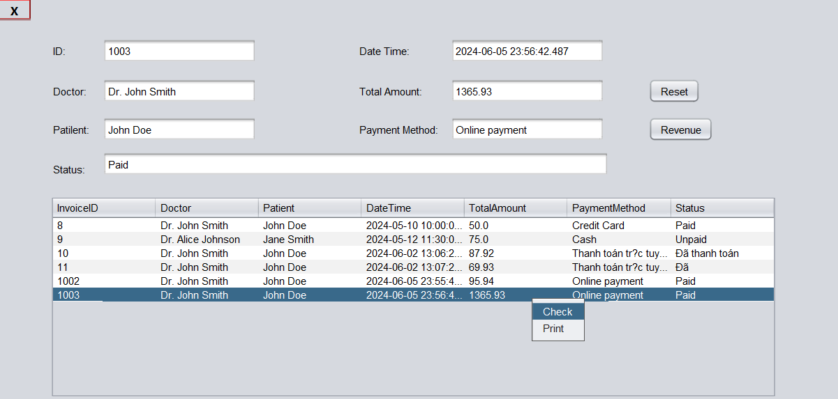

2: Invoice Details Double click on the data you want to view details

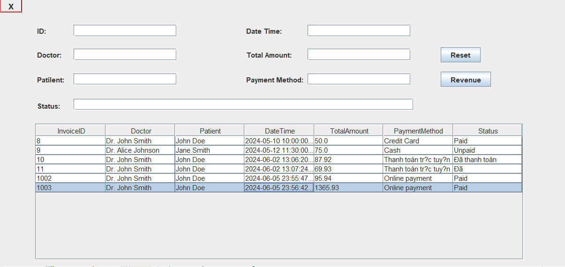

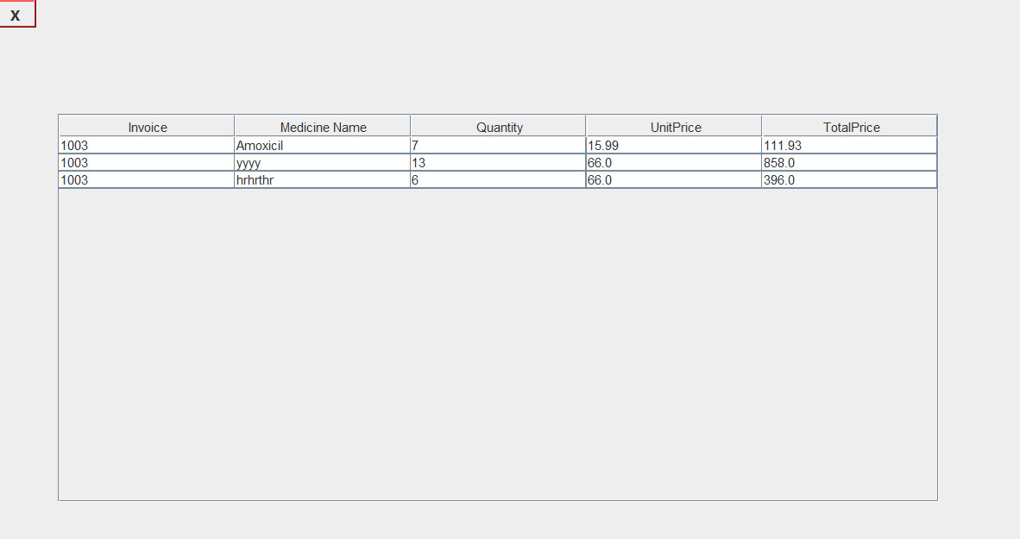

3:Invoice Print Right click on the data you want to print then select print

